**CS551 ADVANCED SOFTWARE ENGINEERING**

**PROJECT- FIRST INCREMENT**

**OCCASIONS ON THE GO**

**Team Members:**

Prathyusha Dinne (16161128)

Anudeep Vattipalli (16158489)

Poojitha Mittapally(16157740)

**Introduction:**

Planning an event is very simple and is on high demand. To plan an event, you need to select every vendor, login to their websites and order the required services. Also, it will be difficult to adapt to different patterns and designs as each vendor has their own in built design. To avoid these problems, our project acts as a single stop where in user can find different vendors in one place with a common user interface (UI). This project provides feasibility to order services both through mobile and web applications. In this application, both users and vendors can take advantage as user will be provided with best deals and vendor can attract customers by giving offers.

Below is the URL of our web application “Occasions on the Go”

**http://kc-sce-cs551.kc.umkc.edu/aspnet_client/Group4/ASE_Project/home.aspx**

**Work Completed till 1st Increment:**

We have created both web pages for user and vendor registration, login authentication and profile updates. Same functionality pages were implemented even in android.

**Implementation Status Report:**

**Work Completed:**

Database plays a vital role in the project. So, for the first increment we have created few tables in the databases. The tables which we have created were:

* User details
* Vendor Details

**User Details Table:**

This table consists of attributes username, password, email, contact number and zipcode.

Queries used on these tables were:

1. Insert into table registration values (name, password, email, contactno, zipcode). These values are picked from the end user feed.
2. Select name, email, contactno, zipcode from registration where name=’username’ and password=’pass’
3. Update registration (username=name, email=email, contactno=contactno, zipcode=zip)

**Vendor Details Table:**

This table consists of attributes vendor name, password, email, contact number and zipcode.

Queries used on these tables were:

1. Insert into table vendor values (name, password, email, contactno, zipcode). These values are picked from the end vendor feed.
2. Select name, email, contactno, zipcode from vendor where name=vendorname and password=’pass’
3. Update vendor (vendorname=name, email=email, contactno=contactno, zipcode=zip)

**Implementation of Services :**

Below services developed as part of this increment is:

1. Facebook API
2. Twitter API

As part of user interface, we have implemented sliding of images on the web pages for effective web page view.

**Screenshots of Web Application:**

**Home Page:**

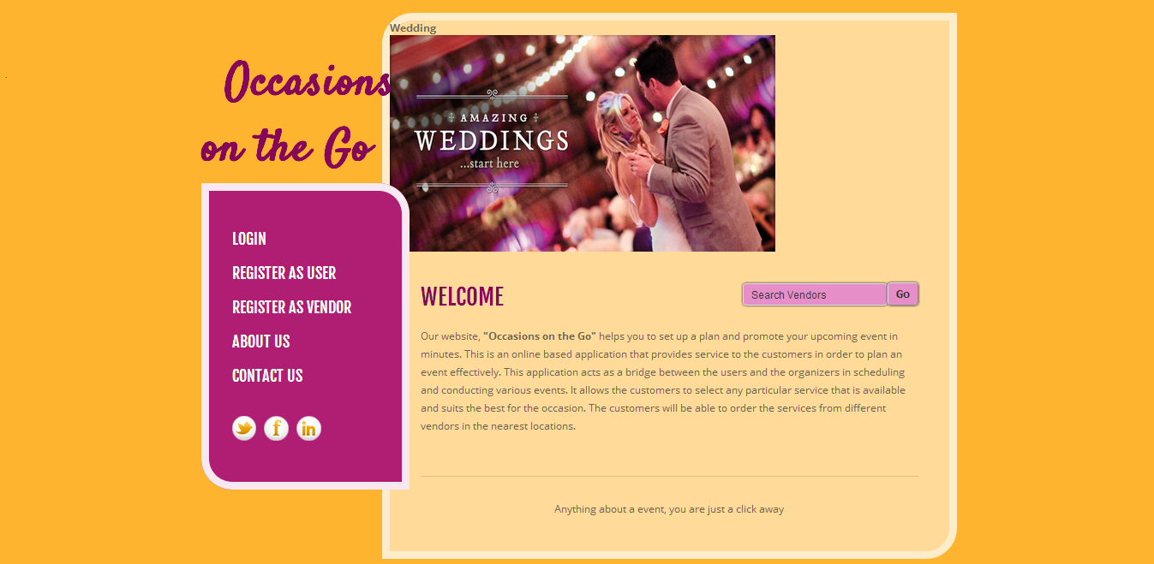

**Login Page:**

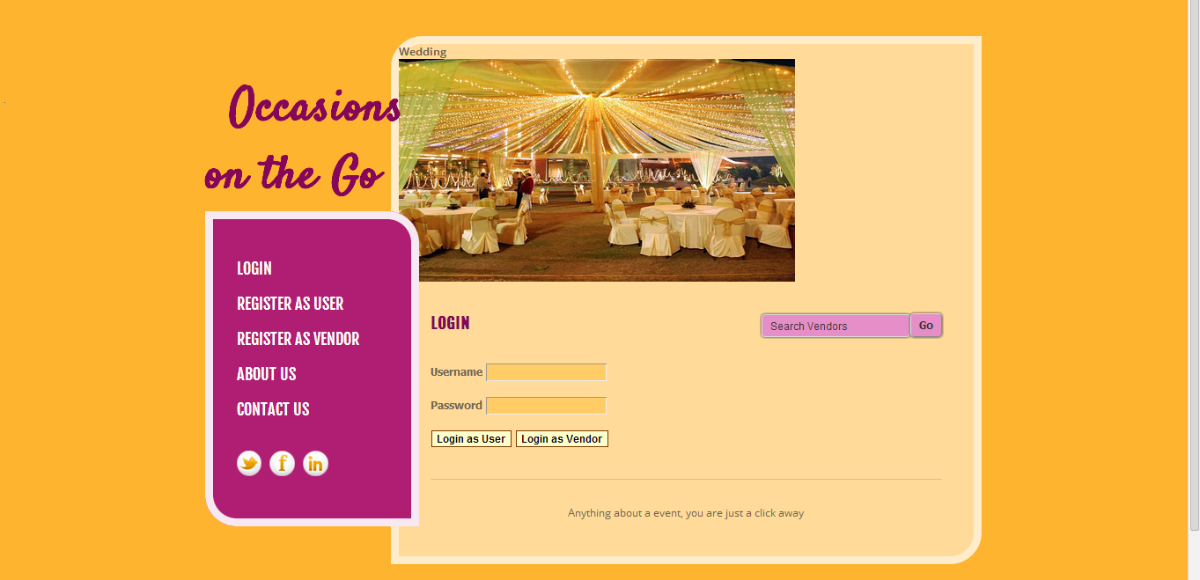

**User Registration Page:**

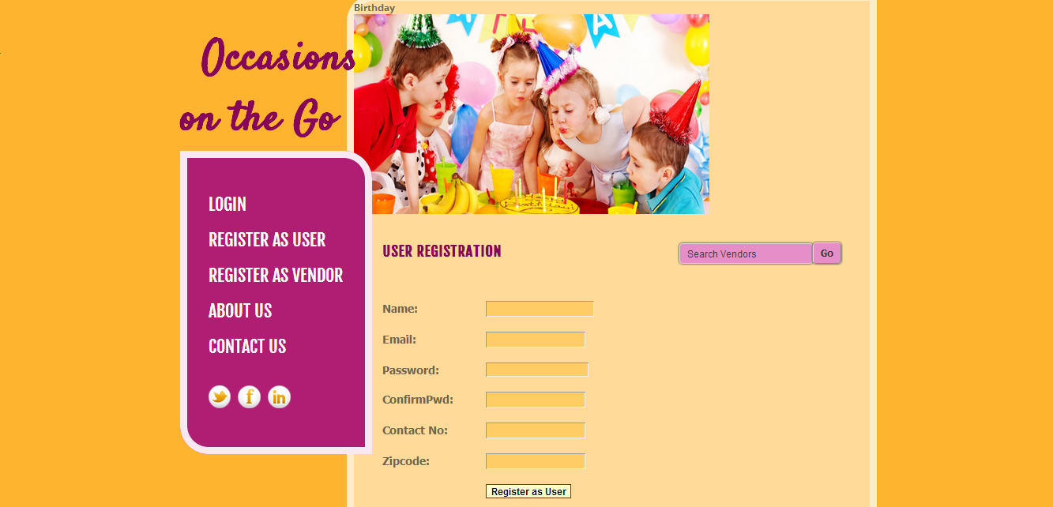

**Vendor Registration Page:**

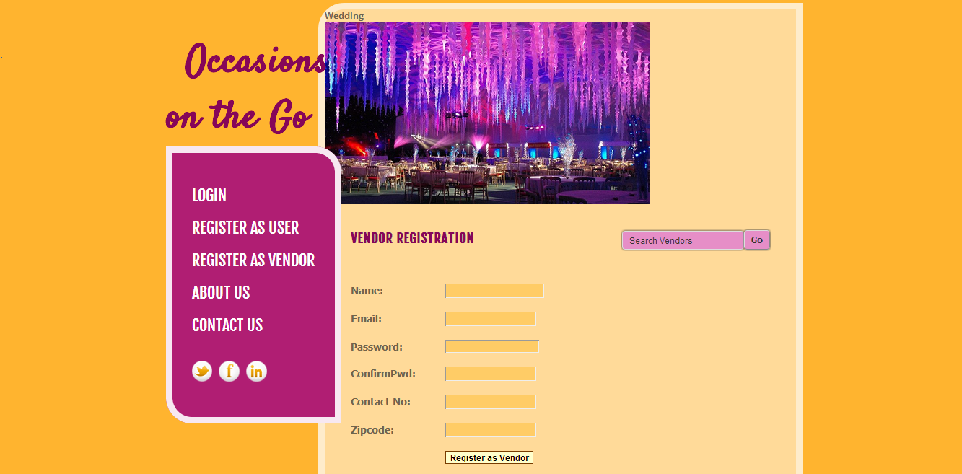

**Android Login Page:**

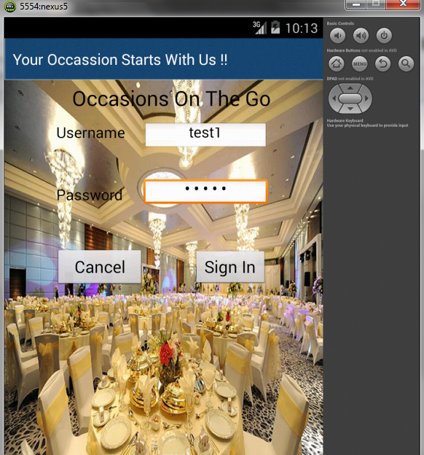

**Android Page after login page:**

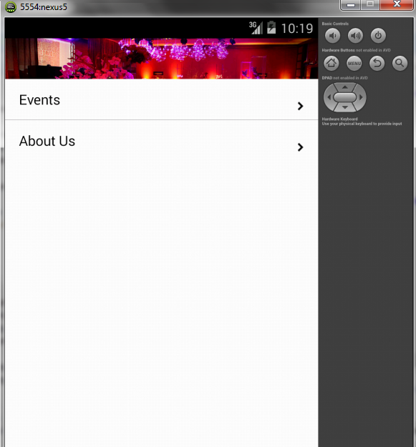

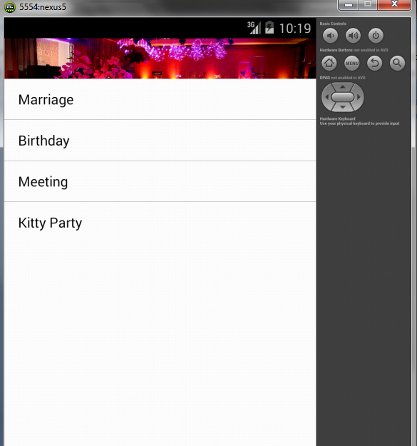

**Responsibilities:**

|  |  |  |  |
| --- | --- | --- | --- |
| **Sl.No** | **Task** | **Person involved** | **Estimated Time** |
| 1. | Designed UI for both web and android application | Prathyusha  Anudeep | 3 hr |
| 2. | Database creation and connection using sql management studio to store user and vendor details | Prathyusha  Anudeep  Poojitha | 1 hr |
| 3. | Create tables to store user details | Poojitha | 2hr |
| 4. | Create sessions to maintain the login details | Prathyusha  Poojitha  Anudeep | 2hr |
| 5. | Create tables to store vendor details | Poojitha | 2hr |
| 6. | API services | Prathyusha | 2 hr |
| 7. | To create android login and home pages | Anudeep | 2hr |
| 8. | Testing | Prathyusha  Anudeep  Poojitha | 2hr |

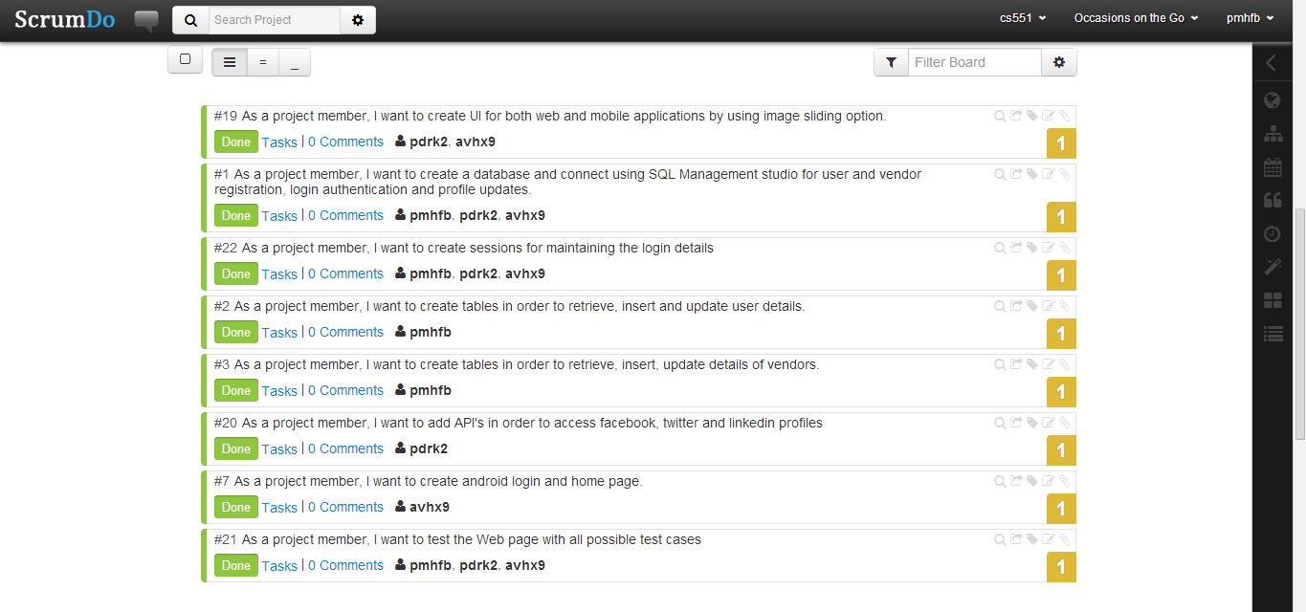

**Work To Be Completed As Part Of 2nd Increment:**

We will be implementing the web services in second increment and link it to database for the search engine and then create a page to display the search results.

**Responsibilities:**

|  |  |  |
| --- | --- | --- |
| **Sl.No** | **Task** | **Person involved** |
| 1. | To create web services for google and facebook | Prathyusha  Anudeep  Poojitha |
| 2. | To create web services for searching the vendor | Prathyusha  Anudeep  Poojitha |
| 3. | To implement web services on android. | Prathyusha  Anudeep  Poojitha |
| 4. | Implementing shopping cart page | Prathyusha  Anudeep  Poojitha |
| 5. | Testing web services using Nunit testing | Prathyusha  Anudeep  Poojitha |
| 6. | Documentation work | Prathyusha  Anudeep  Poojitha |